**King Abdul Aziz University**

**Faculty of Computing and Information Technology**

**Department of Computer Science**

**Senior Project CPCS-499**

Developing an Online Developers Community& auto UML Generator (Report-II)

02.10.2018

## Prepared by

Hazar Gul Nazari (1414322)

Supervisors

Prof. Isa Fathi & Prof. Kamal Jambi

**Table of Contents**

Prepared by 0

Summary of previous work 2

Aim of the project 2

Problem definition 2

Project scope 2

Expected outcome 3

Target Users:- 3

Suggested solution 3

Functional Requirements:- 3

Non-Functional Requirements:- 3

Data Requirements:- 4

Implementation Languages:- 4

Software:- 4

Methods and Approaches 4

Planning 4

Analysis 4

Design 5

Implementation 5

Maintenance 5

Activities and Actions 5

Use Case Diagram:- 5

Flow Chart:- 6

Class Diagram:- 6

Tasks Completed: 7

Interface: 7

# Summary of previous work

## Aim of the project

The aim of this project is to create an application which is an online community for developers. This online community will allow the users to share, ask their ideas or UML diagram by generating UML diagram from the source code automatically. In the future, this project will allow to all types of OOP (Objected-Oriented Programming) languages to generate their UML source code.

## Problem definition

This project is an online software application which focuses on creating an auto UML generator to convert the PHP 5.0 source code into UML diagram. In the future, it can be expanded easily, due to providing such a platform for other languages as well, such as (Java, C++, and other languages that support OOP concept). The problem is, in developing a PHP parser to extract all the Class and Interface information from the source code and finding the solution on how to illustrate the extracted information into diagram by using HTML5 Canvas that could be easier to understand for the user. Also, another part of the problem is to create such a platform to allow users to create a specific group where the developers can share and ask the ideas on a specific topic such as a group for PHP where PHP developers can join and chat with each other about specific PHP topic.

## Project scope

The scope of this project is to:

* Create an auto UML generator from PHP 5.0 source code
* Creating a special communication tool for developers
* Make a platform for future extension of auto UML diagram for other OOP (Object Oriented Programming) languages

## Expected outcome

A full responsive web application that can generate UML diagram from PHP 5 source code, the users can download, share and interact with the generated UML diagram. Besides, the application provides a special communication tool for developers where they could find a specific group and join it for discussion.

## Target Users:-

The target users of this application are the software developers, but in general, anyone can use it for his or her own purpose of generating UML diagram from PHP source code and to communicate with other developers.

## Suggested solution

* Creating a PHP syntax parser for extracting class and interface details from the source code
* Using HTML5 Canvas to draw the extracted information from the PHP source code into visually UML diagram
* Creating the application interface for the chat application

## Functional Requirements:-

* Generate UML diagram
* Download generated UML diagram
* Share generated UML diagram
* Create new group
* Ranking the group
* Putting group in favorite list
* Remove group from favorite list
* Register new account / Sign in account
* Search community
* Send & receive message on chatroom

## Non-Functional Requirements:-

* Response time
* Throughput
* Reliability
* Maintainability

## Data Requirements:-

The user should upload the files which contain the PHP source code, which through the uploaded source code, the UML diagram will be generated.

## Implementation Languages:-

* PHP
* MySQL
* JavaScript
* jQuery libraries
* HTML
* CSS

## Software:-

* NetBeans 8.2
* Windows 10
* XAMP Server (PHP and MySQL compiler)
* Chrome Browser

# Methods and Approaches

## Planning

I planned for the project by using the work break down structure (WBS), scheduled the project by Gantt chart & time estimates to manage & organize my work in order to complete the project.

## Analysis

First, I tackled the analysis and parsing part of PHP syntax analyzer and figure out how to design and implement it to extract the class and interface information from the PHP files. The compiler course which I took last year, really helped me in this part of the project.

Second, I figured out about the illustration part of the UML diagram on the browser page, which is the most important and difficult part of this project. The generated UML diagram will be illustrated in the browser so, therefore, I planned to make use of HTML 5 Canvas to convert the extracted information from the source code into UML diagram in the client side.

Third, it’s the application’s user interface part and also figure about the chat application part and creating the database for the entire application.

## Design

I designed an initial prototype for the project as well as the flow chart, use case diagram and class diagram.

## Implementation

This project is an application which is an implementation based project, therefore I started coding the project. And the coding is divided into 4 parts:

1. Implementation of the PHP syntax parser.
2. Implementation of the UML illustration part into HTML 5 Canvas.
3. Implementation of Chat Application.
4. Creating database for the application.

## Maintenance

After completing the code, I will test the program in order to remove the errors.

# Activities and Actions

## Use Case Diagram:-

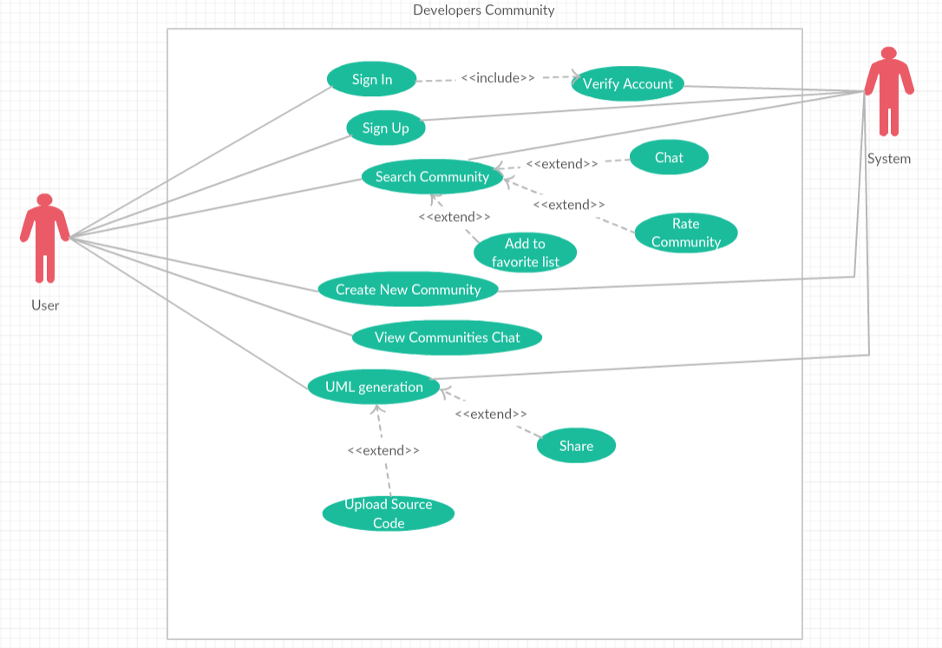

Figure 1this use case shows how the application works

## Flow Chart:-

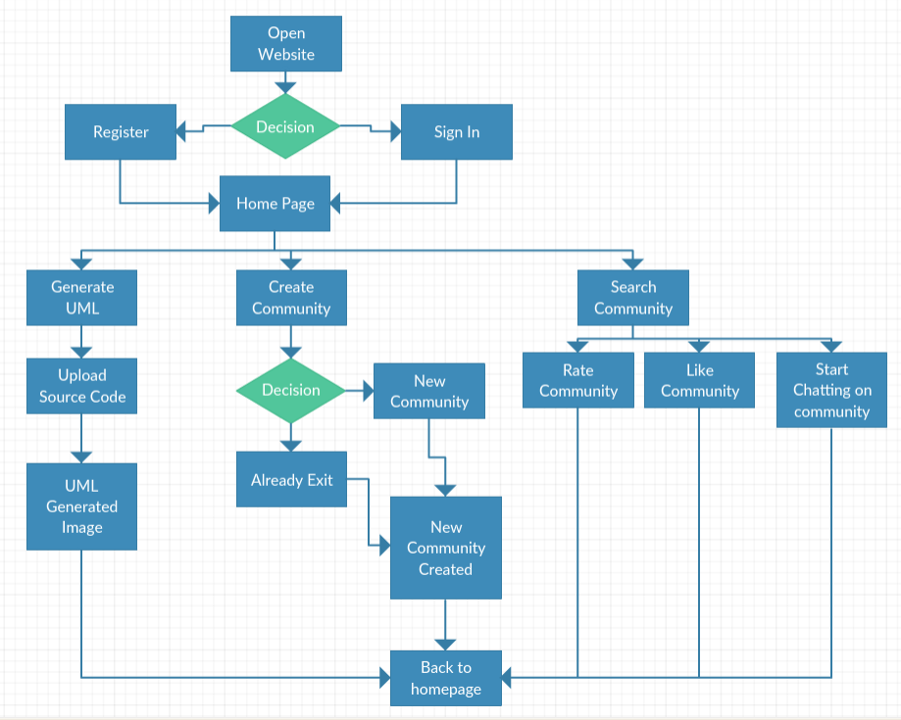

Figure 2 this flow chart explains how the system will work

## Class Diagram:-

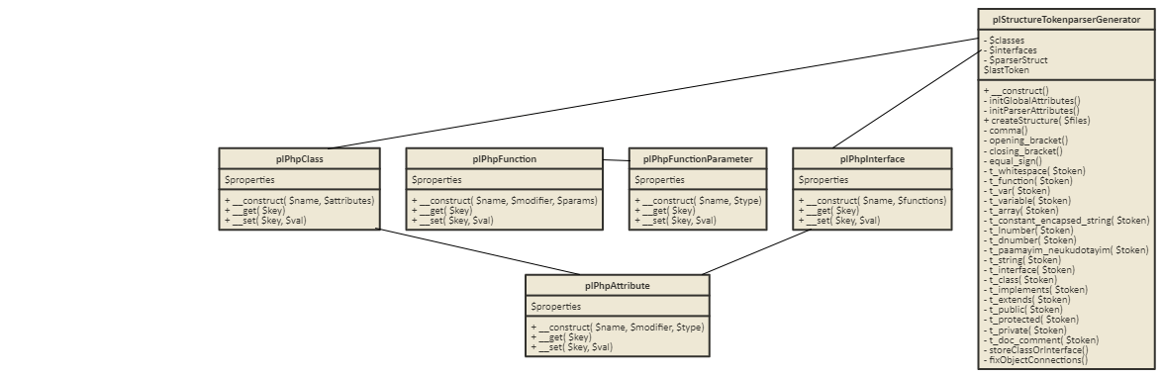

## Tasks Completed:

* PHP syntax parser.
* Printing UML diagram from source code
* Chat Application
* Searching Community
* Creating account
* Editing account
* Generating UML diagram from source code

## Interface:

Here are some of the interface of the project.

1. **The Main Page**: In the main page, there are many options for the users to navigate the entire application, such as, searching a specific group, enter to a specific group’s chat room, creating a new group, putting a specific group into favorite list, sign in/up, and generating UML diagram.

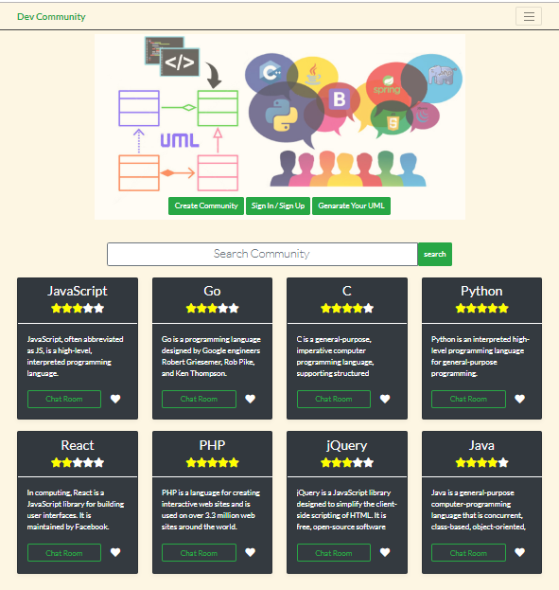

Figure 3shows the main page of the application

1. **Community Information Page**: this page is to get an overall information about a specific language/library and it also allows the user to rate that specific or to join the chatroom.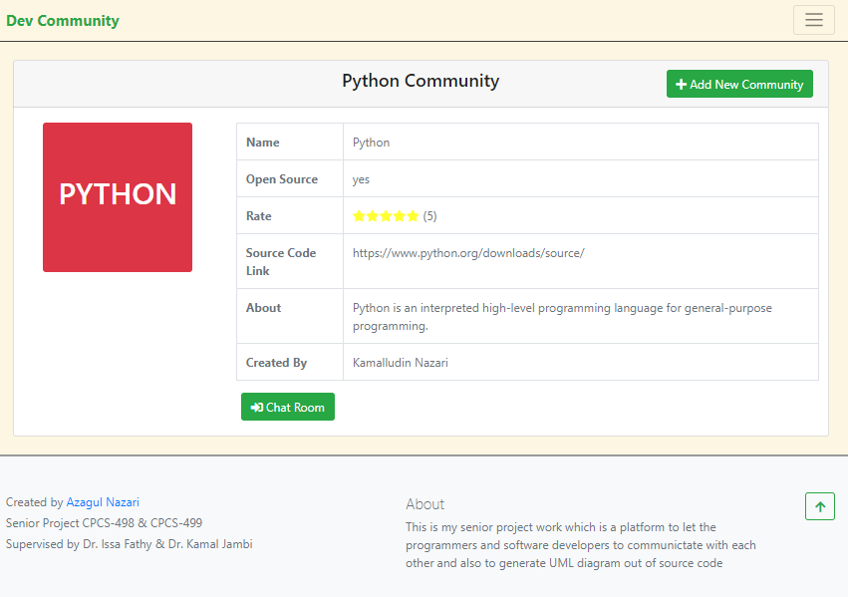

Figure 4 shows the community info page

1. **Sign in/up page**: this page is to let the user to log in or to register a new account in the system. 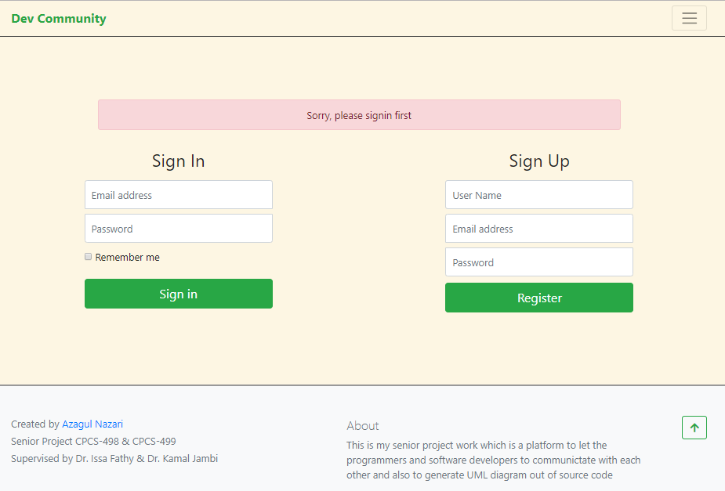

Figure 5shows the sign in and register page

1. **Profile page**: this page is to visit the profile page of the user. The user can see his/her favorite groups list and also he/she can edit his profile information such as email, password, information or profile pic.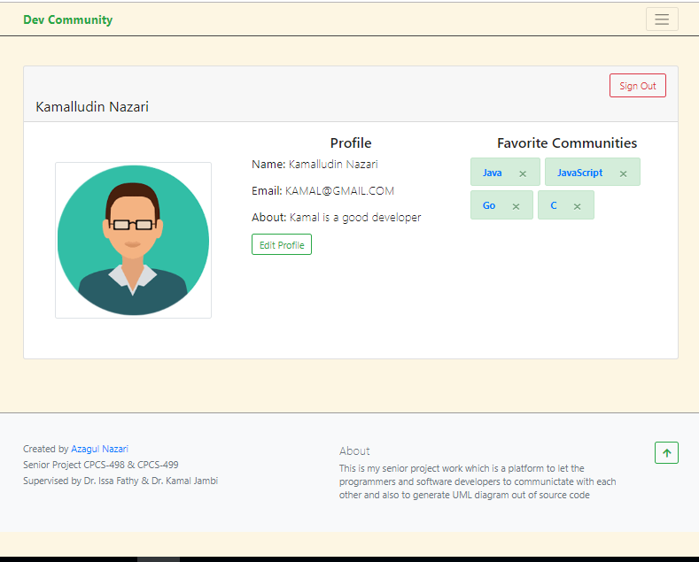

Figure 6shows the user profile information

1. **Profile Edit page**: this page is to edit the user profile. Only the authorized user can edit his profile. 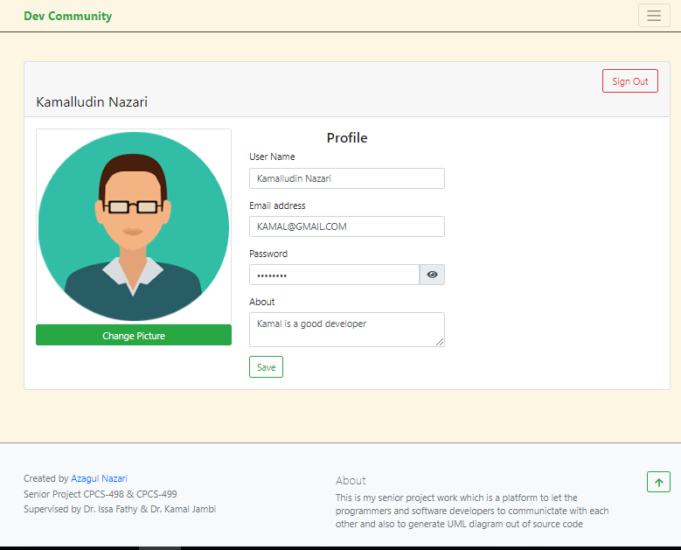

Figure 7shows the profile edit page

1. **Group chatroom page**: this page is to let the developers to chat with each other, they can send messages.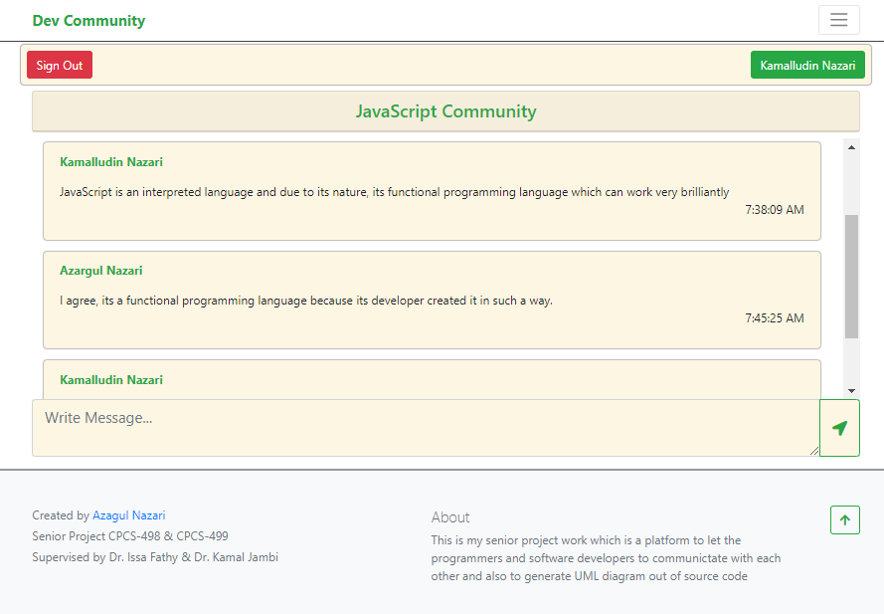

Figure 8shows the chat room for the JavaScript Community

1. **Upload file page:** this page is to let the users to upload PHP files for generating their UML diagram.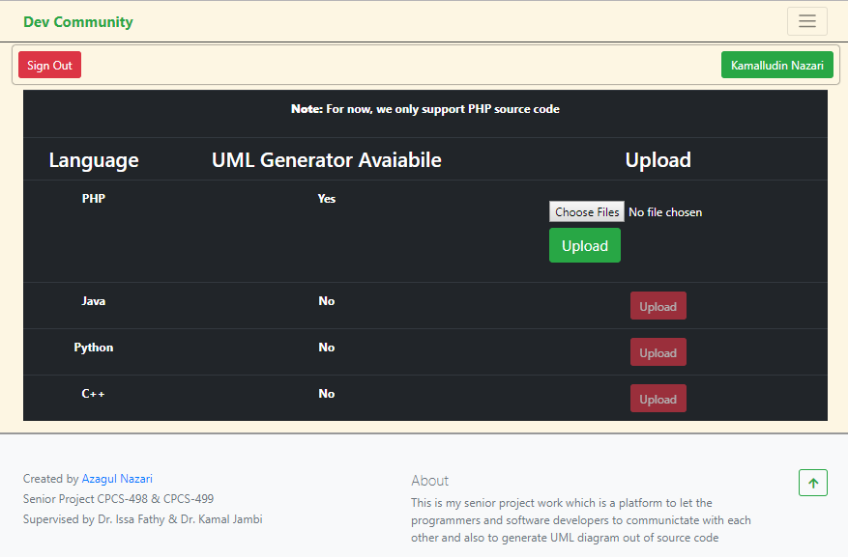

Figure 9Shows the PHP file upload page

1. **UML generated page**: this page is to show the generated UML diagram after uploading process from the above picture. The user can zoom in/out, download UML image, or to share the link. 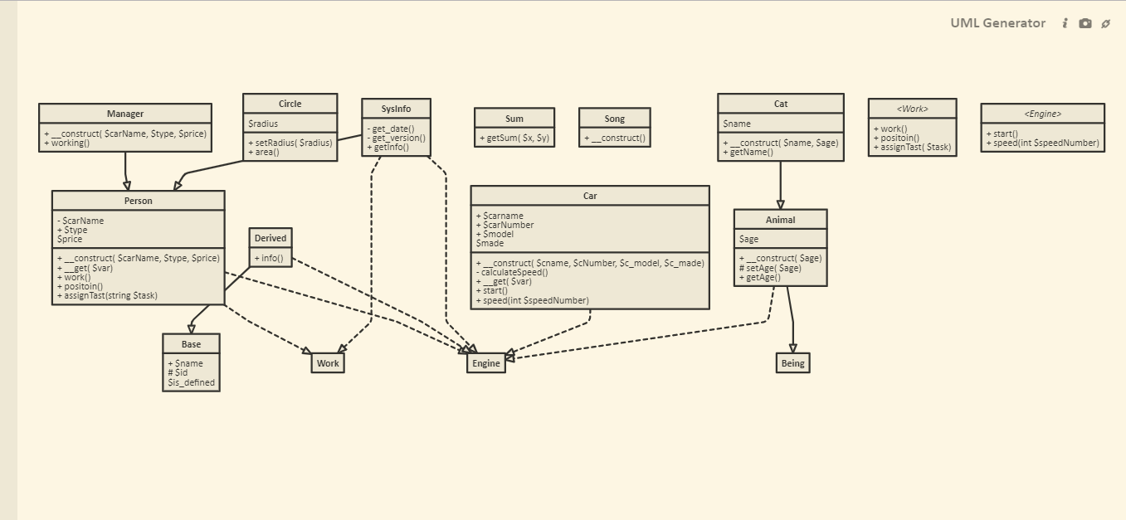

Figure 10shows the generated UML diagram

The generated UML diagram is from the below source code